Linguistic Comparison Between Original Steve Jobs Speech and GPT-Rephrased Text

1. Introduction

This study examines linguistic differences between an original excerpt from *Steve Jobs’ commencement speech at *Stanford University and a rephrased version generated by ChatGPT.

The objective is to identify differences in:
• sentence length
• word frequency usage
• stylistic patterns
• sentiment (tone)

To achieve this, three R packages were used:
• quanteda (word frequency & corpus analysis)
• tidytext (sentiment analysis)
• stylo (stylometric comparison)

Additionally, udpipe was used to extract part-of-speech (POS) patterns.

⸻

2. Data Preparation

The original text was extracted from a PDF file and cleaned by:
• removing headers and footers
• deleting page markers (e.g., “Session One”)
• normalizing whitespace
• splitting text into sentences using punctuation rules

The same preprocessing pipeline was applied to the ChatGPT-generated text to ensure consistency.

After cleaning:
• Original text: 36 sentences
• ChatGPT text: 34 sentences

⸻

3. Methodology
3.1 Sentence Length Analysis

Sentence length was computed as the number of tokens per sentence.

A density plot was generated using ggplot2 to compare distributions between the two texts.

⸻
3.2 Word Frequency Analysis (quanteda)

The quanteda package was used to:
• tokenize the corpus
• remove punctuation
• build a document-feature matrix (DFM)
• extract top frequent words

This approach captures stylistic tendencies through function words and common vocabulary, which are widely used in authorship and tone studies.

3.3 Sentiment Analysis (tidytext)

The tidytext package was used with the Bing sentiment lexicon, which classifies words into:
• positive
• negative

This provides a lexicon-based operationalization of tone.

3.4 Stylometric Analysis (stylo)

The stylo package was used to perform Correspondence Analysis (CA) based on Most Frequent Words (MFW).

This method captures deeper stylistic differences beyond simple frequency counts, and is commonly used in computational stylistics.

3.5 POS-Based Structural Analysis (udpipe)

Part-of-speech tagging was performed using udpipe, and tags were simplified into categories such as:
• N (nouns)
• V (verbs)
• J (adjectives)
• R (adverbs)

This allows comparison of grammatical structure and stylistic patterns.

Linguistic Comparison/
├── config.R
├── functions.R
├── pipeline.R
├── Transcription_scripts_Session0.pdf
├── chatgpt-Steve Jobs.pdf
├── corpus/
├── output/

4. Results
4.1 Sentence Length

A two-sample t-test shows:
• Mean sentence length (original): 18.14 words
• Mean sentence length (ChatGPT): 18.06 words
• p-value ≈ 0.97

Interpretation:
The distributions largely overlap, suggesting structural consistency between original and GPT-rephrased text.
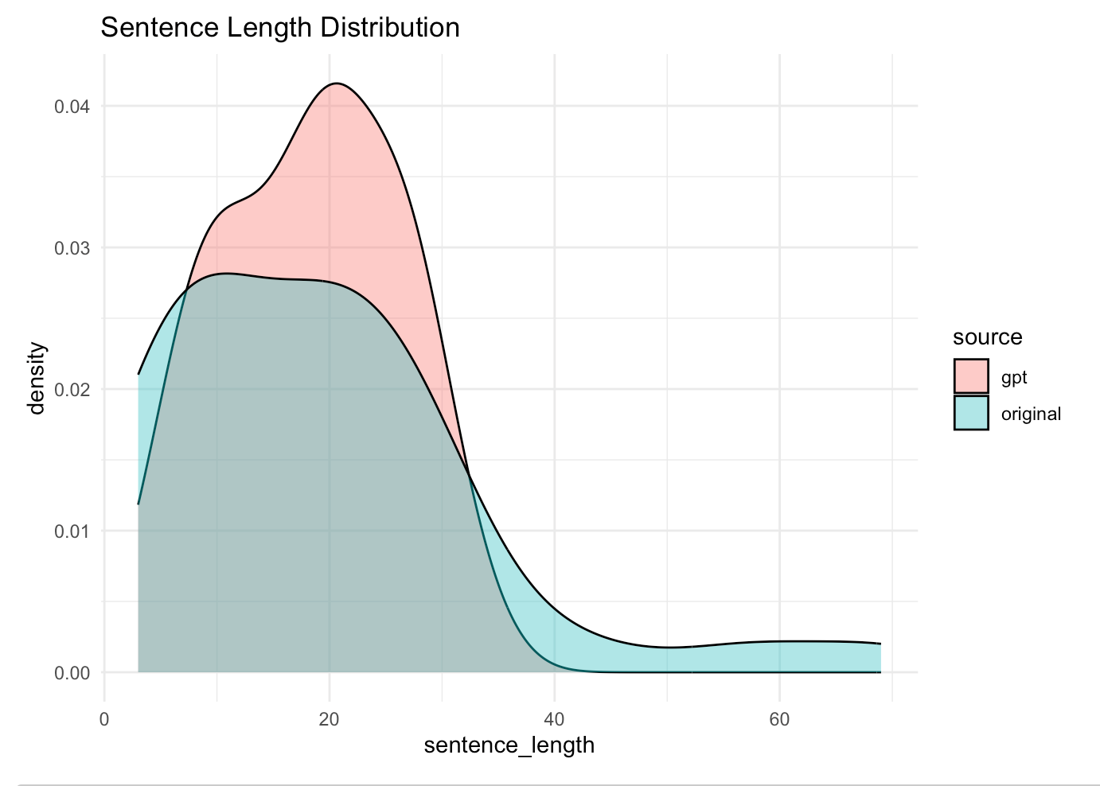
⸻

4.2 Word Frequency Differences

Top features show:

Original text:
• higher use of: the, to, and, college, that

ChatGPT text:
• relatively more use of: would, with, for

Interpretation:
• ChatGPT introduces more modal verbs (e.g., “would”), indicating slightly more formal or explanatory tone
• The original text uses more direct and conversational phrasing

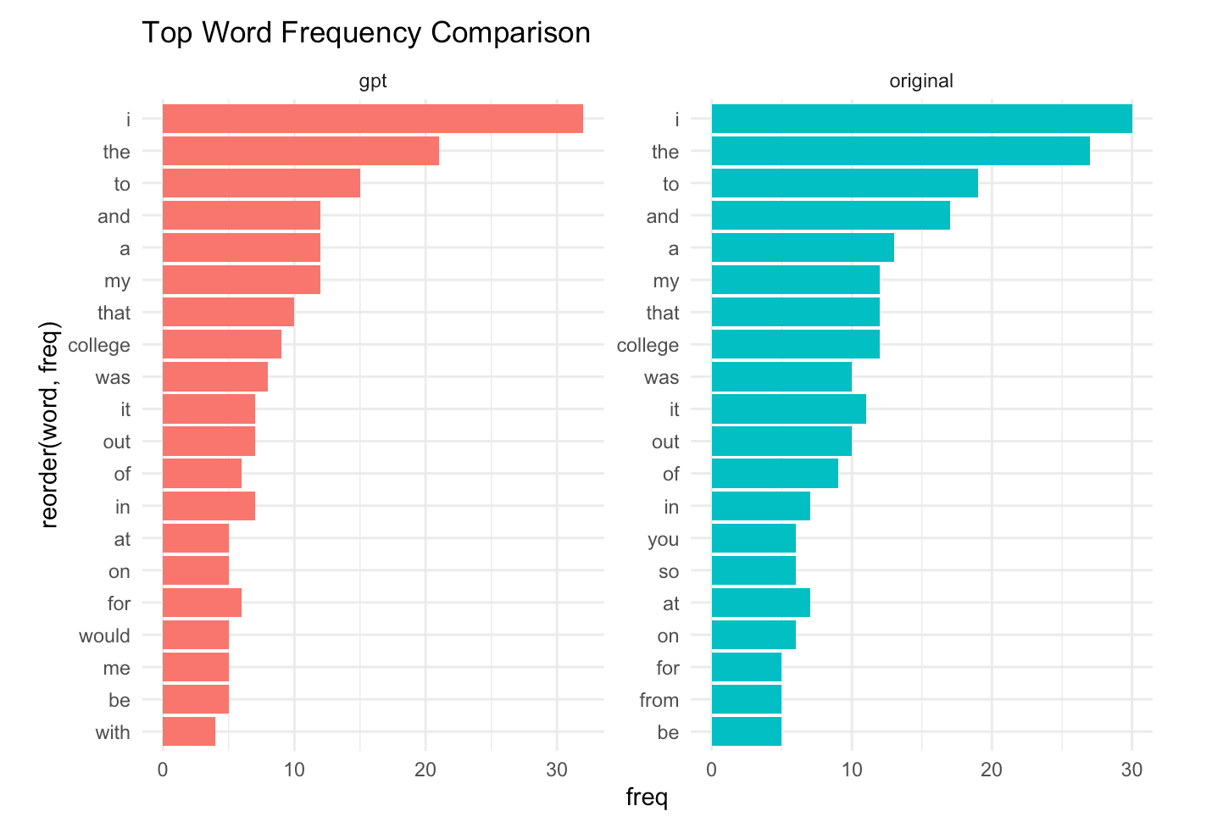⸻
4.3 Sentiment Analysis

Results:

Source Positive Negative
Original 20 6
ChatGPT 19 6

Interpretation:
• Sentiment distribution is nearly identical
• ChatGPT successfully preserves emotional polarity
• Tone differences are not driven by sentiment, but by style
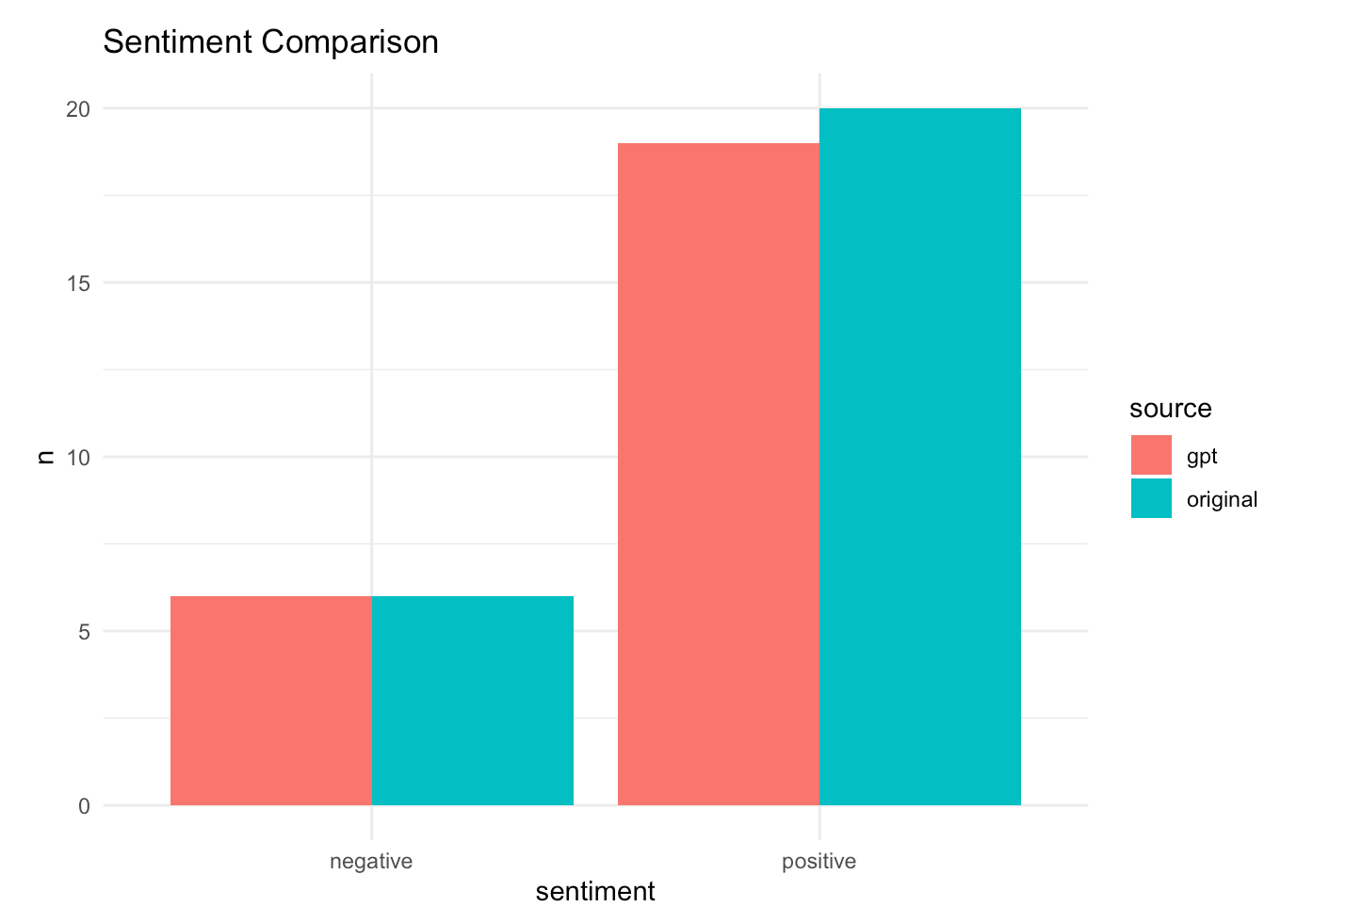
4.4 Stylometric Analysis (stylo)

Correspondence Analysis (CA) based on Most Frequent Words shows:
• Original and ChatGPT texts form distinct stylistic clusters

Interpretation:
Even though content and sentiment are similar, stylo detects measurable stylistic divergence, indicating:
• differences in word choice patterns
• differences in stylistic consistency
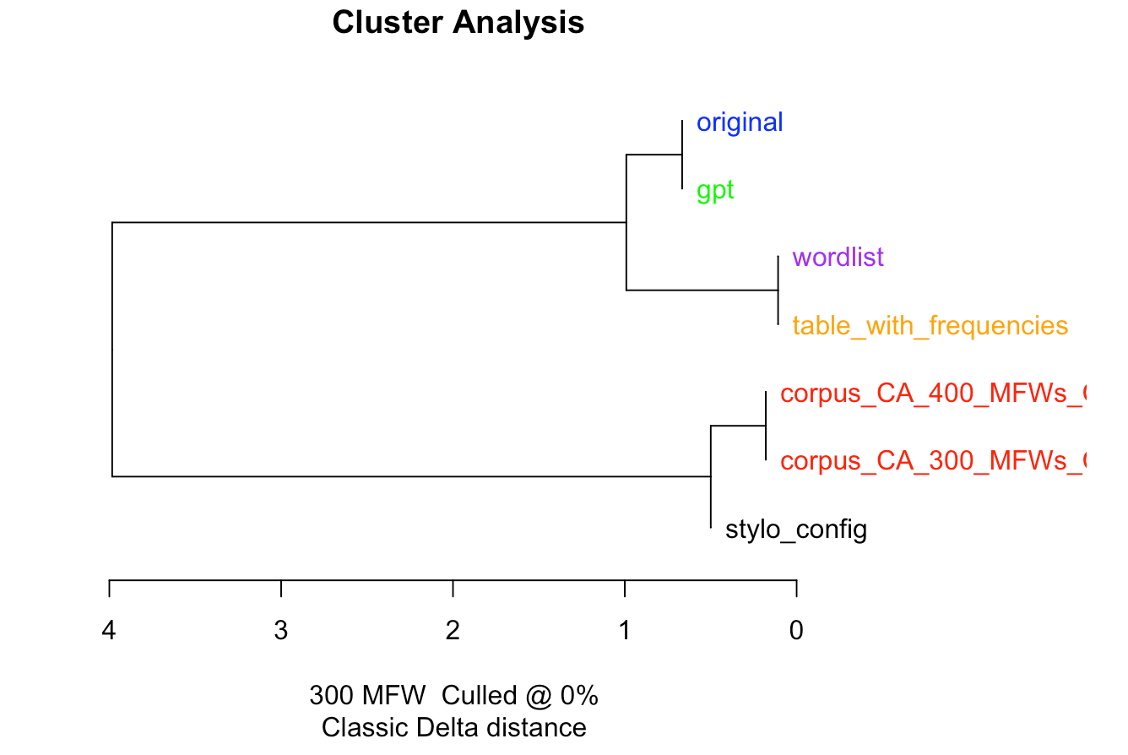
⸻

4.5 Structural (POS) Patterns

POS sequence analysis shows:
• Similar high-level structure (pronoun + verb + noun patterns)
• ChatGPT tends to:
• slightly increase auxiliary verbs
• use more structured sentence constructions

Interpretation:
ChatGPT produces text that is:
• more grammatically regularized
• slightly more formalized

5. Discussion
The results suggest that ChatGPT maintains:
• sentence length
• sentiment polarity
• overall semantic meaning

However, it modifies:
• lexical choices (word frequency differences)
• stylistic patterns (detected by stylo)
• grammatical structure (POS distribution)

In particular:
• ChatGPT introduces more formal and structured phrasing
• The original text is more conversational and narrative-driven

6. Conclusion
This study demonstrates that tone is multi-dimensional and cannot be captured by sentiment alone.

Different computational approaches reveal different aspects:
• tidytext → emotional tone (no major difference)
• quanteda → lexical choices (moderate difference)
• stylo → stylistic fingerprint (clear difference)
• udpipe → grammatical structure (subtle difference)

Overall, ChatGPT preserves meaning but shifts the text toward a more formalized and standardized style.

7. Tools and Context
• quanteda: corpus-based word frequency and lexical analysis
• tidytext: lexicon-based sentiment analysis
• stylo: stylometric comparison using most frequent words
• udpipe: syntactic annotation and POS tagging

These tools were applied in a unified pipeline to ensure consistent preprocessing and comparability.

